|  |  |  |  |  |  |  |  |
| --- | --- | --- | --- | --- | --- | --- | --- |
| DANCE | | | | | | | |
|  | EYFS | Year 1 | Year 2 | Year 3 | Year 4 | Year 5 | Year 6 |
| Copy basic body actions and rhythms. | Copy, remember and repeat actions. | Copy, remember and repeat a series of actions. | Copy remember and perform a dance phrase | Copy, remember and adapt set choreography. | Accurately copy and repeat set choreography in different styles of dance showing a good sense of timing. | Perform dances confidently and fluently with accuracy and good timing. |
| Choose and use travelling actions, shapes and balances. | Choose actions for an idea. | Select from a wider range of actions in relation to a stimulus. | Create short dance phrases that communicate an idea. | Choreograph considering structure individually, with a partner and in a group. | Choreograph phrases individually and with others considering actions, dynamics, space and relationships in response to a stimulus. | Work creatively and imaginatively individually, with a partner and in a group to choreograph longer phrases and structure dance considering actions, space, relationship and dynamics in relation to a theme. |
| Travel in different pathways using the space around them. | Use changes of direction, speed and levels with guidance. | Use pathways, levels, shapes, directions, speeds and timing with guidance | Use canon, unison and formation to represent an idea. | Use action and reaction to represent an idea. | Confidently perform choosing appropriate dynamics to represent an idea. | Improvise and combine dynamics demonstrating an awareness of the impact on performance. |
|  | Begin to use  dynamics and  expression with  guidance. | Show some sense of dynamic and expressive qualities. | Use mirroring and unison when completing actions with a partner. | Match dynamic and and expressive qualities to a range of ideas. | Change dynamics to express changes in character or narrative. | Use counts accurately when choreographing to perform in time with others and the music. | Use counts when choreographing and performing to improve the quality of work. |
|  | Begin to count to music. | Begin to use counts. | Show a character through actions, dynamics and expression. | Use counts to keep in time with a partner and group | Use counts when choreographing short phrases. |  |  |
|  |  |  | Use counts with help to stay in time with the music. |  |  |  |  |
| FUNDAMENTAL MOVEMENT SKILLS | | | | | | | |
|  | EYFS | Year 1 | Year 2 | Year 3 | Year 4 | Year 5 | Year 6 |
|  | Run and stop with some control. | Attempt to run at different speeds showing awareness of techniques. | Show balance and co-ordiantion when running at different speeds. | Show balance, co-ordination and technique when running at different speeds, stopping with control. | Demonstrate how and when to speed up and slow down when running. | Run at the appropriate speed over longer periods or for longer periods of time. | Demonstrate a controlled running technique using the appropriate speed over longer distances or for longer periods of time. |
| Explore skipping as a travelling action. |
|  | Jump and hop with bent knees. | Begin to link running and jumping movements with some control. | Link Running and jumping movements with some control and balance. | Link running, hopping and jumping actions using different take offs and landing. | Link hopping and jumping actions with some control. | Show control at take-off and landing in more complex jumping activities. | Link running, jumping and hopping actions with greater control and co-ordination. |
|  | Throwing larger balls and beanbags into space. | Jump, leap and hop choosing which allows them to jump furthest. | Show jumping and hopping movemnts with some balance and control. | Jump for distance and height with an awareness of technique. | Jump for distance and height showing balance and control. | Perform a range of more complex jumps showing some technique. | Perform jumps for height and distance using good technique. |
|  | Balance whilst stationary and on the move. | Throw towards a target. | Change technique to throw for distance. | Throw a variety of objects, changing action for accuracy and distance. | Throw with some accuracy and power towards a target area. | Show accuracy and power when throwing for distance. | Show accuracy and good technique when throwing for distance. |
|  | Change direction at a slow pace. | Show some control and balance when travelling at different speeds. | Show control and balance when traavelling at different speeds. | Demonstrate balance when performing other fundamental skills. | Demonstrate good balance when performing other fundamental skills. | Demonstrate good balance and control when performing other fundamental skills. | Show fluency and control when travelling, landing, stopping and changing direction. |
|  | Explore moving different body parts. | Begin to show balance and co-ordination when changing direction. | Demonstrates balance and co-ordiantion when changing direction. | Show balance when changing direction in combination with other skills. | Show balance when changing direction at speed in combination with other skills. | Demonstrate improved body posture and speed when changing direction. | Change direction with a fluent action and can transition smoothly between varying speeds. |
|  |  | Use co-ordination with and without equipment. | Perform actions with increased control when co-ordinating their body with and without equipment. | Can co-ordinate their bodies with increased consistency in a variety of activities. | Begin to co-ordinate their body at speed in response to a task. | Can co-ordinate a range of body parts at increased speed. | Can co-ordinate a range of body parts with a fluent action at speed appropriate to the challenge. |
| GAMES | | | | | | | |
|  | EYFS | Year 1 | Year 2 | Year 3 | Year 4 | Year 5 | Year 6 |
| Drop and catch with two hands. | Drop and catch a ball after one bounce on the move. | Dribbles a ball with two hands on the move. | Dribble the ball with one hand with some control in game situations. | Link dribbling the ball with other actions with increasing control. | Use dribbling to change direction of play with some control under pressure. | Use dribbling to change the direction of play with control under pressure. |
| Move a ball with feet. | Move a ball using different parts of the foot. | Dribble a ball with some success, stopping it when required. | Dribble a ball with feet in some control in game situations. | Change direction when dribbling with feet with some control in game situations. | Dribble with feet with some control under increasing pressure. | Use a variety of dribbling techniques to maintain possession under pressure. |
| Throw and roll a variety of beanbags and larger balls to space. | Throw and roll towards a target with some varying techniques. | Throw and roll towards a target using varying techniques with some success. | Use a variety of throwing techniques in game situations. | Use a variety of throwing techniques with increasing success in game situations. | Use a variety of throwing techniques with some control under increasing pressure. | Use a variety of throwing techniques including fake passes to outwit an opponent. |
|  | Kick larger balls to space. | Kick towards a stationary object. | Show balance when kicking towards a target. | Kick towards a partner in game situations. | Kick with increasing success in game situations. | Use a variety of kicking techniques with some control under increasing pressure. | Select and apply appropriate kicking technique with control. |
|  | Stop a beanbag or large ball sent to them using hands. | Catch a beanbag and a medium-sized ball. | Catch an object passed to them, with and without a bounce. | Catch a ball passed to them using one and two hands with some success. | Catch a ball passed to them using one and two hands with increasing confidence. | Catch and intercept a ball using one and two hands with some success in game situations. | Catch and intercept a ball using one and two hands with increasing success in game situations. |
|  | Attempt to stop a large ball sent to them using feet. | Attempt to track balls and other equipment sent to them. | Move to track a ball and stop it using feet with limited success. | Receive a ball sent to them using different parts of the foot. | Receive a ball using different parts of the foot under pressure. | Receive a ball using different parts of the foot under pressure with increasing control. | Receive a ball with consideration to the next move. |
|  | Hit a ball with hands. | Strike a stationary ball using a racket. | Strike a ball using a racket. | Strike a ball with varying techniques. | Strike a ball using varying techniques with increasing accuracy. | Strike a ball using a wider range of skills. Apply these with some success under pressure. | Strike a ball using a wider range of skills to outwit an opponent. Apply these with increasing control under pressure. |
|  | Run and stop when instructed. | Run, stop and change direction with some balance and control. | Run, stop and change direction with balance and control. | Change direction with increasing speed in game situations. | Change direction to lose an opponent with some success. | Use a variety of techniques to change direction to lose an opponent. | Confidently change direction to successfully outwit an opponent. |
|  | Move around showing limited awareness of others. | Recognise space in relation to others. | Move to space to help score goals or limit others scoring. | Use space with some success in game situations. | Create and use space with some success in game situations. | Create space for self and others with some success. | Effectively create and use space for self and others to outwit an opponent. |
|  | Make simple decisions in response to a situation. | Begin to use simple tactics with guidance. | Use simple tactics. | Use simple tactics individually and within a team. | Use simple tactics to help their team score or gain possession. | Understand the need for tactics and can identify when to use them in different situations. | Work collaboratively to create tactics within their team and evaluate the effectiveness of these. |

|  |  |  |  |  |  |  |  |
| --- | --- | --- | --- | --- | --- | --- | --- |
| GYMNASTICS AND BODY MANAGEMENT | | | | | | | |
|  | EYFS | Year 1 | Year 2 | Year 3 | Year 4 | Year 5 | Year 6 |
| Create shapes showing a basic level of stillness using different parts of their bodies. | Perform balances making their body tense, stretched and curled. | Perform balances on different body parts with some control and balance. | Complete balances with increasing stability, control and technique. | Use body tension to perform balances both individually and with a partner. | Show increasing control and balance when moving from one balance to another. | Combine and perform more complex balances with control, technique and fluency. |
| Begin to take weight on different body parts. | Take body weight on hands for short periods of time. | Take body weight on different body parts with and without apparatus. | Demonstrate some strength and control when taking weight on different body parts for longer periods of time. | Demonstrate increasing strength, control, and technique when taking own and others weight. | Use strength to improve the quality of an action and the range of actions available. | Demonstrate more complex actions with a good level of strength and technique. |
| Show shapes and actions to stretch their bodies. | Demonstrate poses and movements that challenge their flexibility. | Show increased awareness of extension and flexibility in actions. | Demonstrate increased flexibility and extension in their actions. | Demonstrate increased flexibility and extension in more challenging actions. | Use flexibility to improve the quality of the actions they perform as well as the actions they choose to link them. | Confidently transition from one action to another showing appropriate control and extension for the complexity of the action. |
|  | Copy and link simple actions together. | Remember, repeat and link simple actions together. | Copy, remember, repeat and plan linking simple actions with some control and technique. | Choose actions that flow well into one another both on and off apparatus. | Plan and perform sequences showing control and technique with and without a partner. | Create and perform more complex sequences of actions with a good level of quality, control and technique with and without a partner. | Plan and perform with precision, control, and fluency, a sequence of actions including a wide range of skills. |

|  |  |
| --- | --- |
| Purpose and Impact | |
| Defending conclusions reached | By defending conclusions, using given sentence stems, students think more critically about a broad range of skills, learning how to use them in different ways and to link them to make actions and sequences of movement. |
| Group discussion | The purpose of group discussion is to inspire curiosity so that students know more about ways in which they can support their health and fitness. Further to this, within P.E students should enjoy communicating, collaborating and competing with each other. |
| Self – Reflection | Through the oracy progression, students are invited to change their mind based on what they have heard. In doing so, pupils develop their understanding of how to improve in different physical activities and sports and learn how to evaluate and recognise their own success. |
| Competition | Within P.E at St Joseph’s, we heavily promote competition. Within this competition, students are expected to speak appropriately, showing support for their peers at all times. |
| Leadership | When engaging in school events, pupils are expected to display leadership skills through verbal means. In doing so, students need to be able to articulate their needs and that of their peers to team mates and staff. |

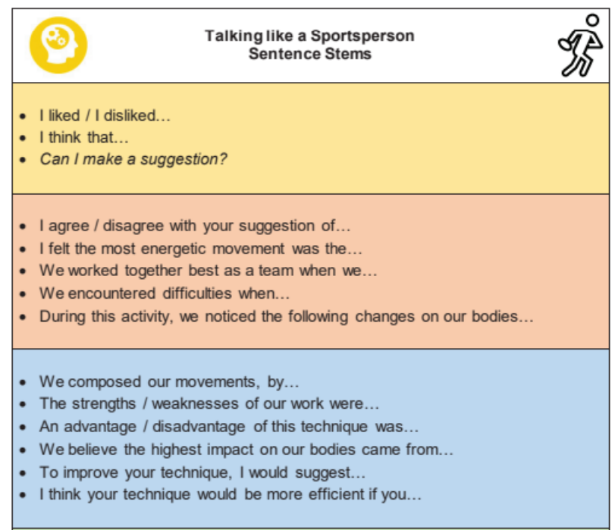

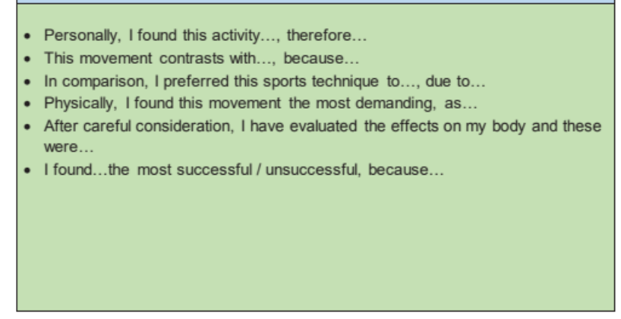

|  |  |  |  |  |  |  |  |
| --- | --- | --- | --- | --- | --- | --- | --- |
| OUTDOOR ADVENTUROUS ACTIVITIES | | | | | | | |
|  | EYFS | Year 1 | Year 2 | Year 3 | Year 4 | Year 5 | Year 6 |
| Follow simple instructions. | Follow instructions. | Follow instructions accurately. | Follow instructions from a peer and give simple instructions. | Accurately follow instructions given by a peer and give clear and usable instructions to a peer. | Use clear communication when working in a group and taking on different roles. | Communicate with others clearly and effectively when under pressure. |
| Share their ideas with others. | Begin to work with a partner and a small group. | Work co-operatively with a partner and a small group, taking turns and listening to each other. | Work collaboratively with a partner and a small group, listening to and accepting ideas. | Confidently communicate ideas and listen to others before deciding the best approach. | Begin to lead others, providing clear instructions. | Confident to lead others and show consideration of including all within a group. |
| Explore activities making their own decisions in response to a task. | Understand the rules of the game and suggest ideas to solve simple tasks. | Try different ideas to solve a task. | Plan and attempt to apply strategies to solve problems. | Plan and apply strategies to solve problems. | Plan and apply strategies with others to more complex challenges. | Use critical thinking skills to form ideas and strategies selecting and applying the best method to solve a problem. |
|  | Make decisions about where to move in space. | Copy a simple diagram/map. | Follow and create a simple diagram/map. | Orientate and follow a diagram/map. | Identify key symbols on a map and use a key to help navigate around a grid. | Orientate a map confidently using it to navigate around a course. | Confidently and efficiently orientate a map, identifying key features to navigate around a course. |
|  | Follow a path. | Identify own and others’ success. | Understand when a challenge is solved successfully and begin to suggest simple ways to improve. | Reflect on when and why challenges are solved successfully and use others’ success to help them to improve. | Watch, describe and evaluate the effectiveness of their team strategy, giving ideas for improvements. | Explain why a particular strategy worked and alter methods to improve. | Accurately reflect on when challenges are solved successfully and suggest well thought out improvements. |
|  | Begin to identify personal success. |  |  |  |  |  |  |

|  |  |  |  |  |
| --- | --- | --- | --- | --- |
| SOCIAL, EMOTIONAL AND THINKING | | | | |
| SOCIAL | EYFS | Years 1 and 2 | Years 3 and 4 | Years 5 and 6 |
| Take turns. | Encourage others to keep trying. | Encourage and motivate others to work to their personal best. | Share ideas with others and work together to decide on the best approach to a task. |
| Learn to share equipment with others. | Talk to a partner about their ideas and take turns to listen to each other. | Work with others to achieve a shared goal. | Lead others and show consideration of including all within a group. |
| Share their ideas with others. | Work with a partner and small group to play games and solve challenges. | Work with others to self-manage games. | Communicate with others clearly and effectively. |
| EMOTIONAL | EYFS | Years 1 and 2 | Years 3 and 4 | Years 5 and 6 |
| Try again if they do not succeed. | Show determination to continue working over a longer period of time. | Persevere when finding a challenge difficult. | Understand what maximum effort looks and feels like and show determination to achieve it. |
| Practise skills independently. | Determined to complete the challenges and tasks set. | Understand what their best looks like and they work hard to achieve it. | Use different strategies to persevere to achieve personal best. |
| Confident to try new tasks and challenges. | Explore skills independently before asking for help. | Begin to use rules, showing awareness of fairness and honesty. | Compete within the rules showing fair play and honesty when playing independently. |
|  | Confident to share ideas, contribute to class discussion and perform in front of others. | Show an awareness of how other people feel. | Confident to attempt tasks and challenges outside of their comfort zone. |

|  |  |  |  |  |
| --- | --- | --- | --- | --- |
| THINKING | EYFS | Years 1 and 2 | Years 3 and 4 | Years 5 and 6 |
| Begin to identify personal successes. | Make decisions when presented with a simple challenge. E.g. move to an open space towards goal. | Pupils make quicker decisions when selecting and applying skills to a situation. E.g. who to pass to and where to move. | Reflect and evaluate their performances both as a group and as an individual and suggest areas for improvement. |
| Choose own movements and actions in response to simple tasks e.g. choosing to travel by skipping. | Begin to select and apply skills to use in a variety of differing situations. E.g. choose to use a balance on their bottom on a wider piece of apparatus. | Select and apply from a wider range of skills and actions in response to a task. | Recognise and explain their thought process when playing games or completing tasks. E.g. I moved here because my teammate was over there. |
| Begin to provide simple feedback saying what they liked or thought was good about someone else’s performance. | Provide feedback beginning to use key words from the lesson. | Provide feedback using key terminology. | Identify their own and others’ strengths and areas for development providing sensitive feedback and can suggest ways to improve. |
|  |  |  | Select and apply appropriate skills for the situation when under pressure. |

|  |  |  |
| --- | --- | --- |
| SWIMMMING | | |
| Beginners | Developers | Intermediate |
| Submerge and regain feet in the water. | Confidently and consistently retrieve an object from the floor with the same breath. | Confidently combine skills to retrieve an object from greater depth. |
| Breathe in sync with an isolated kicking action from poolside. | Begin to co-ordinate breath in time with basic strokes showing some consistency in timing. | Confidently co-ordinate a smooth and consistent breathing technique with a range of strokes. |
| Use arms and legs together to move effectively across a short distance in the water. | Demonstrate a fair level of technique, consistently co-ordinating the correct body parts in a range of strokes. | Confidently demonstrate good technique in a wider range of strokes over increased distances. |
| Glide on front and back over short distances. | Combine gliding and floating on front and back over an increased distance. | Combine gliding and transitioning into an appropriate stroke with good control. |
| Float on front and back for short periods of time. | Float on front and back using different shapes with increased control. | Confidently link a variety of floating actions together demonstrating good technique and control. |
| Confidently roll from front to back and then regain a standing position. | Comfortably demonstrate sculling head first, feet first and treading water. | Select and apply the appropriate survival technique to the situation. |