Curriculum Overview
Year 5 – Route B
 | Autumn Term 1 | Autumn Term 2 | Spring Term 1 | Spring Term 2 | Summer Term 1 | Summer Term 2
 | Why should we remember the Maya? | Where should we go on holiday? | What did the Greeks do for us? | How is our county changing? | Did WWI or WWII have the biggest impact on our locality? | Are we damaging our world?
English | 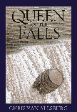  Queen  of the  Falls  Diary | 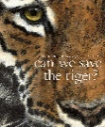  Can We  Save the  Tiger  Hybrid  Information,  Explanation,  and Persuasion, Narrative | 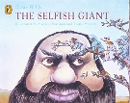  The Selfish  Giant  Narrative  Non  Chronological | The Darkest  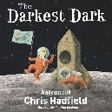  Dark  Biography | 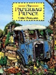  Paperbag  Prince  Hybrid  Persuasive  Information/  Explanation  Leaflet | 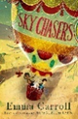  Sky Chasers  Autobiography
Maths  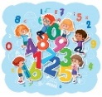 | Place Value  Addition and Subtraction  Multiplication and Division A  Fractions A |  | Multiplication and Division B  Fractions B  Decimals and Percentages  Perimeter and Area  Statistics |  | Shape  Position and Direction  Decimals  Negative Numbers  Converting units  Volume
RE | Creation  CAFOD: Stewardship  Buddhism - stewardship | God’s Covenants  Hindu - Dharma | Inspirational People  Ghandi, Malala Yousafazi, Kailash Satyarthi, | Reconciliation | Life in the Risen Christ | Other Faiths  Judaism, Islam, Sikhism, Buddhism,
Science | Y6 Light and sight | Y5 Separating mixtures | Y5 Forces | Y6 Classifying Living Things | Y5 Earth and Space
Computing | Y6: Digital Literacy/E-Safety – It’s cool to be kind.  Looking at cyber bullying and online interactions. | Y5: Computer Science -Catch the Dots Maya Game. | Y5: Computer Science – To plan and create an interactive game or animation based on North America. | Y6: Information Technology – Digital Journey – children to create and upload their own VR Google Expedition of their journey through North America. | Y6: Computer Science – Scratch Maths – Building with Numbers. Using variables, inputs/outputs. | Y6: Information Technology – End of year animation.  Children to plan, write and produce an end of year video, stop-motion or flip-book including soundtrack composed by them.
PE  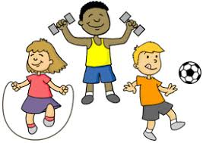 | Rugby  Dance | Football  Netball | Hockey  OAA | Dodgeball  Gymnastics | Striking and Fielding  (Rounders/Cricket)  Athletics | Net and Wall (Tennis/Volleyball)  Swimming  Athletics
Geography |  | Focusing on diverse Alpine regions, children will use maps to focus on countries, cities and regions in Europe.  They will be taught to understand a region of another European country. They will be taught to understand some of the physical and human processes that shape a region. |  | Focusing on our local areas, children will name and locate counties and cities of the UK. They will also identify geographical regions and their identifying human and physical characteristics, key topographical features (including hills, mountains, coasts and rivers), and land-use patterns; and understand how some of these aspects have changed  over time. Children will also understand geographical similarities and differences through the study of human and physical geography of a region of the UK. |  | In this unit the children will focus on the damage to the environment and what can be done to fix it. They will describe and understand key aspects of the distribution of natural resources including energy, minerals and water.  Children will use maps, atlases and globes to locate countries and describe features studied.
History  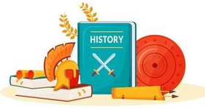 | In this unit, the children will explore the world of the Maya, and debate whether they should continue to be remembered today as a significant culture. They will establish clear narratives within and across periods they study. They will also regularly address historically valid questions about similarity and difference and significance. |  | In this unit, the children will learn about aspects of political, social and cultural Ancient Greek life. The children will develop the use of historical terms and address and devise historically valid questions. They will understand how our knowledge of the past is constructed from a range of sources. |  | In this unit, the children will research and compare the impact of the First and Second World Wars on their locality. The children will develop a chronologically secure knowledge and understanding of British, local and world history. They will also address and devise historically valid questions about change, cause and significance.
Music | Hey, Mr Miller  Swing music, Syncopation  Big band, Scat singing, Historical context WWII | Shadows  Artist and their influences, Musical comparisons, Shadows by Lindsay  Sterling  Composing for protest!  To create music  inspired by Ethel Smyth  and a picture of the  suffragettes, Composing using a non-musical stimulus, Lyrics, Melody, Steady beat, Tempo, Ostinato, Coda | Dona nobis pacem  3-part round/polyphonic  texture), ¾ time, church  music in Latin | Ain’t gonna let nobody  Civil rights movement, Spiritual, gospel, RnB, choral  Vocal improvisation, Chords C minor and G7 | Ame sau vala tara bal  Indian music,Raag Bhairavi  Chaal rhythm, Indian musical instruments,Indian musical styles: Bhangra, Bollywood, Indian, Classical | Nobody knows (The  Lumineers)  Songwriting, Chords, Writing lyrics on theme of  ‘leavers’
Art |  | Photography  Artist Study - David Hockney  Investigate Hockney and his work, create a piece of artwork using photograph in his style of the local area |  | Drawing  Artist Study – Giacometti - Self-portrait’s children can use charcoal and more detail. Discuss effect. | Printing  Create posters to promote rationing and the war effort
Design and Technology | Design, make and evaluate: Weaving  Research and design how Mayan’s used weavings and textiles. Learn how to weave on a loom. Return to the weaving over time so skills are practised and developed. Apply skills and learning to create a weaving using recyclable materials. (Bike wheels, baskets, colanders) Create own Mayan weaving selecting from a wide range of textiles. |  | Design, make and evaluate: Foods  Evaluate and investigate a range of existing products.  Understand and apply the principles of a healthy and varied diet. Understand the source, seasonality and characteristics of a broad range of ingredients.  Cook a repertoire of savoury Greek food |  |  | Design, make and evaluate: Invention  Research a range of different lamps, including ones with levers. Investigate how they work. Design your own reading lamp, using a lever and a switch and bulb. Apply their understanding of computing to programme, monitor and control their products.  Create your own reading lamp, using a lever and a switch and bulb
MFL | School Superhoers  School subjects  Calendar  Opinions/feelings  Time; o’clocks and daily routine  Asking and answering a like and dislike  Following a story and exploring more detailed text  Exploration of 1st, 2nd and 3rd person singular and verbs | Stepping into a New World  Nouns and adjectives  House nouns  Descriptive sentences using nouns and adjectives  Numbers to 100  Dialogues to buy items and tickets  Describing a place | Making food that is fit and healthy  Fruits and vegetables and recipes  Instructional text  Make a healthy lunch box  Write, read aloud and perform “masterchef” recipes  Speaking and writing creative sentences | It’s Me!  Clothes nouns and use of adjectives to describe clothes  Reading and speaking descriptive sentences – fancy dress  Finding out about favourite things  Speaking and writing descriptive sentences – presentation “all about me” | A meal in Outer Space  Café’s  Dialogues  Asking and answering questions  Investigating information about foods in short texts  Designing out of this world meals and menus  Understanding, remembering, recalling and performing a sketch | Summer Sports Day  Sports nouns and opinions  Exploring the present tense of the verb “to play”  Exploring text to understand and re-use language  Speaking and writing extended sentences  Performing to an audience
RSE/PSHE  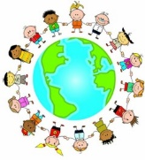 | UKS2.1.1 Kester’s Adventures – Made to Grow | UKS2.1.2.1 Gifts and Talents  UKS2.1.2.2 Girls’ Bodies  UKS2.1.2.3 Boys’ Bodies  UKS2.1.2.4 Spots and Sleep | UKS2.1.3.1 Body Image  UKS2.1.3.2 Funny Feelings  UKS2.1.3.3 Emotional Changes  UKS2.1.3.4 Seeing Stuff Online | UKS2.2.3.1 Sharing Online  UKS2.2.3.2 Chatting Online |  | UKS2.3.1.1 Trinity House  UKS2.3.2.1 Reaching Out
P4C  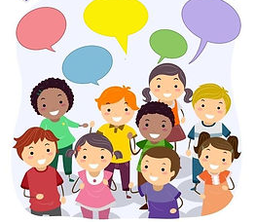 | Begin recording own enquiry  Evaluating the 4C’s progress  Identifying and recording the progress of an enquiry.  Justify reasons with evidence and examples  Can set own stimulus  Can weigh up reasons for agreeing/disagreeing  Can think of different answers for the same question |  | Explaining reasoning and investigating further questions  Using the question technique to identify concepts, assumptions and interpretations.  Refining the P4C question as a class.  Begins to review process and how it can be improved  Explaining reasoning and investigating further questions  Can give other points of view  Can push for decisions about what they think |  | Planning own enquiry  Interrogating an idea more deeply.  Being able to self - reflect and review whole class progress.  Pupils facilitating the enquiry.  Reviewing and evaluating P4C  Can change and improve their own thinking

